**Safe Space Scheme - Member Information**

Thank you for being part of the Safe Space Scheme.

**What’s the purpose of the scheme?**

To be a part of a network of locations across the county offering a safe space for individuals to go to if they’re out and feel unsafe, threatened or at risk of harm.

Provide the facility for someone to make a phone call in a quiet space to a loved one or call the police if needed.

**What are we asking of you?**

* To provide a safe place where someone can wait until the Police or a trusted contact can reach them, or they have been able to access any necessary information and advice to keep them safe
* Offer a private or quiet area with seating that is not accessible to the public, should the person wish to use it. (It doesn’t need to be a fully private room, but it should offer a sense of safety and minimal interruption).
* To provide access to a phone to call Sussex Police or a trusted contact, if needed
* To provide access to a toilet and drinking water whilst they are accessing the Safe Space

**What are you NOT being asked to do?**

* Act as an emergency service – if there is an immediate risk of harm to you or the person seeking help, please call 999
* Get involved in any incident which has resulted in someone seeking your help
* Provide a support service

**What do I do if someone seeks help?**

***Are they at immediate risk?*** Call 999 and stay with them until the Police arrive

***Is there someone they trust who can come and collect them?*** Provide access to a phone if required, and offer to wait with them until that trusted contact arrives

**For further support and advice:**

Please visit [www.safespacesussex.org.uk](http://www.safespacesussex.org.uk) and under ‘Support Services’ there is a wide range of local services available for additional information and support.

They can also contact Victim Support Sussex on 0808 168 9274 during office hours, or reach their 24/7 Supportline at 08 08 16 89 111, or via their live chat function: [WhosOn Chat: Start Chat Session](https://livechat.victimsupport.org.uk/newchat/chat.aspx?domain=safespacesussex.org.uk&timestamp=1752750804219&session=7-1752750804219)

If you have any queries please contact [commissioning@sussex-pcc.gov.uk](mailto:commissioning@sussex-pcc.gov.uk)

**Feedback:**

Anyone who has accessed a safe space, or any business or organisation that has signed up, can share their feedback through the website: www.safespace.org.uk or via the QR codes below:

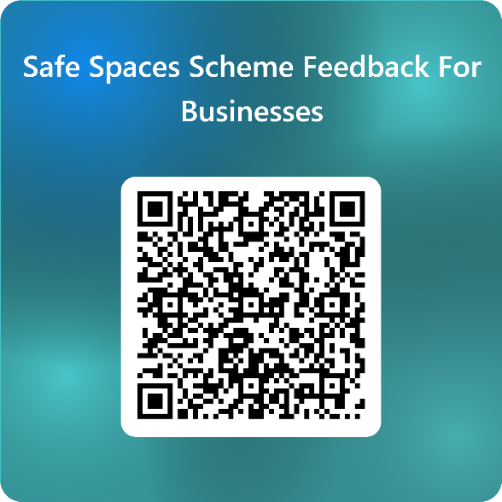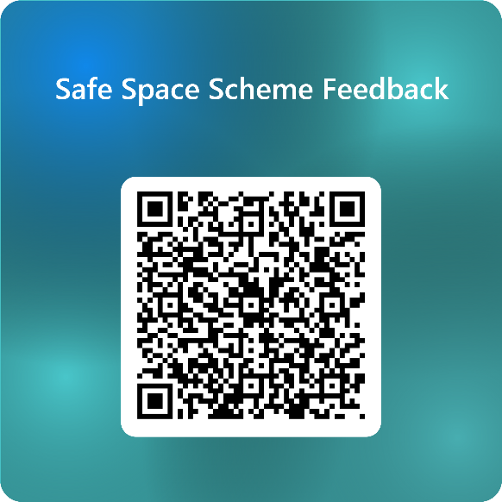

If you have any questions, please contact the commissioning team at Sussex PCC by emailing [commissioning@sussex-pcc.gov.uk](mailto:commissioning@sussex-pcc.gov.uk).